CAMP AJAWAH – 2023
Campers suggested packing list
Use this list to help pack, and then to assist campers to remember what to pack for home.
The quantities listed are just a suggestion. You know your camper best, send the appropriate clothing for 13 days. There is no laundry available.
A plastic tub is great for packing items (optional), it will keep them dry. It should not be taller than 20 inches, as it must slide under the cots.

Mailing address:
CAMP AJAWAH
21600 Zodiac Avenue NE, Wyoming, MN 55092
CLOTHING
Qty | Description |  | Qty | Description
 | Shorts (5) |  |  | 1 sturdy pair of shoes/running shoes
 | Long sleeved/flannel type shirts (2) |  |  | Pair of old shoes for mucking up
 | Sweatshirts (3-4) |  |  | Socks (several pair), including 1 warm
 | Jeans, pants (3) |  |  | Bathing suit (or 2 or 3, they stay wet)
 | T-shirts, tank tops (1 per day) |  |  | Hat (1 or 2)
 | Under garments |  |  | Bandanna(s)
 | Pajamas (or shorts and t to sleep in) |  |  | Rain gear (coat or poncho, boots)
 | 1 pair sandals/flip flops
Girls Camp - A special outfit/sundress for “RITZ’ dinner on 2nd to last night of camp!
BEDDING
Tents are raised wooden platforms with flaps on side in case of rain.
Cots have a structure to attach a mosquito net, stores to purchase will be at bottom of list.
Qty | Description |  | Qty | Description
 | Sleeping bag or sheets and blanket for cot |  |  | Ground cloth, can be old plastic tarp or tablecloth for campfire
 | Pillow, pillowcase(s)
 | Blanket for campfire
 | Beach towels (2 or 3)
 | Old sheet for mattress cover
 | Mosquito net for cot (see below)

HYGIENE
Qty | Description |  | Qty | Description
 | Toothbrush and toothpaste |  |  | Sunscreen
 | Comb and brush |  |  | Mosquito spray (lots!)
 | Bath towels, washcloths |  |  | Hair ties
 | Soap |  |  | Feminine care (tampons, pads)
 | Shampoo
 | Shower/sink caddy (ice cream bucket) |  |  | Mosquito after bite lotion (calamine or itch sticks)
 | Deodorant
 | Hand sanitizer

MISCELLANEOUS ITEMS
Qty | Description |  | Qty | Description
 | $20.00 for trading post (remainder will be reimbursed last day of camp) |  |  | Stationery, pens, stamps. For younger campers, preaddressed and stamped postcards.
 | Water bottle (labeled with name)
 | 1 duffle bag for overnights |  |  | Laundry bag
 | Flashlight and batteries
 | Small crate or plastic bin, or set of shelves, for storage of odds and ends and personal items. |  |  | Sports gear, if desired. (Baseball glove, Jackknife, fishing gear.)
 | A few ziplock bags for art projects or other items. |  |  | Scout handbooks for Scouts

MEDICATIONS AT NURSES CABIN
Please make a list of medications for the nurses cabin, to be picked up at the end of camp.
Qty | Description |  | Qty | Description

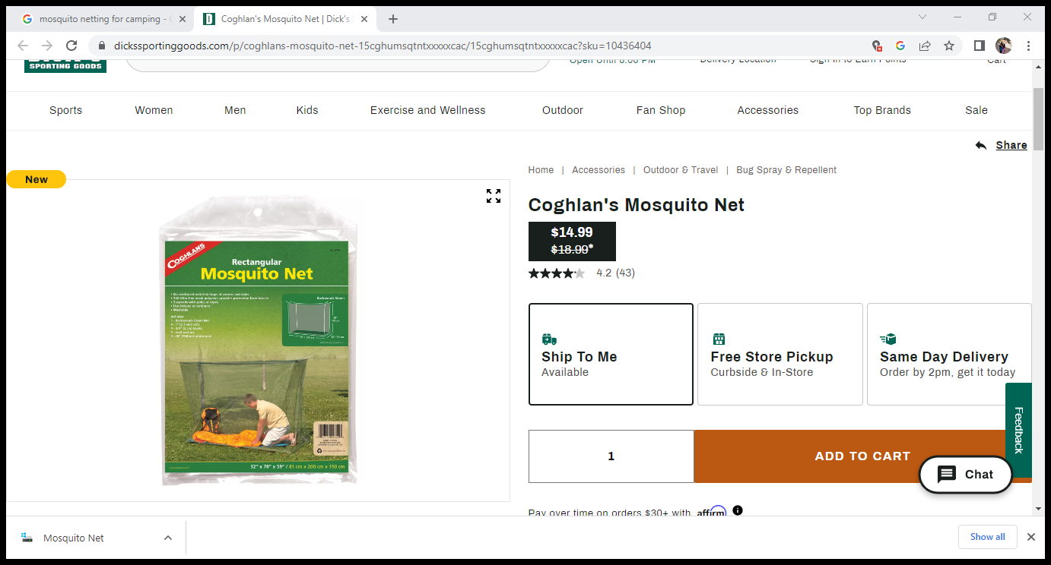

This is an example of the mosquito netting. It can be found at Dick’s, Amazon, REI or other sporting goods stores.

